**Electrical Engineering 2**

**Lab4 Report: Introduction to Measurement Automation-2**

**Authors: Mohammad Bagheri , Miika Kolu , Justice Brobbey Acheampong**

**Date: 26th June‘ 2012**

**Prof: Dr Rasmus Rettig**

**Contents :**

**-Introduction**

**-Screen shots of lab tasks: Front panel/Back panel**

**-Difficulties during the lab**

**Introduction:**

In this Lab, We should design an Ultra sound radar car. By means of the ultra sound radar on this car, it should be able to detect the object on its path and avoid them. We approach to this goal via some lab tasks sequentially.

**Task 6: Arrays, graphs, statistics and saving**

**A: Back panel (Design)**

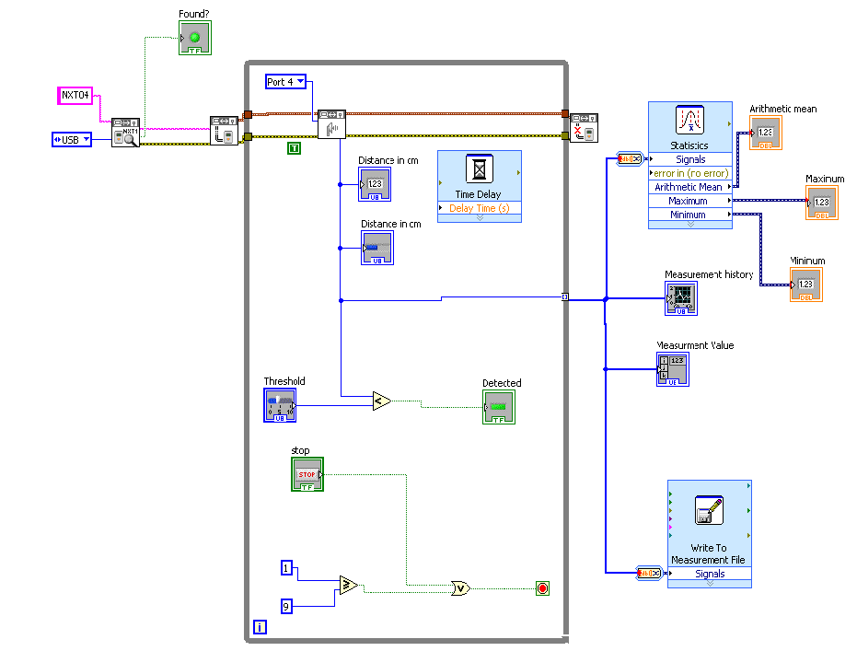

**B: Front panel**

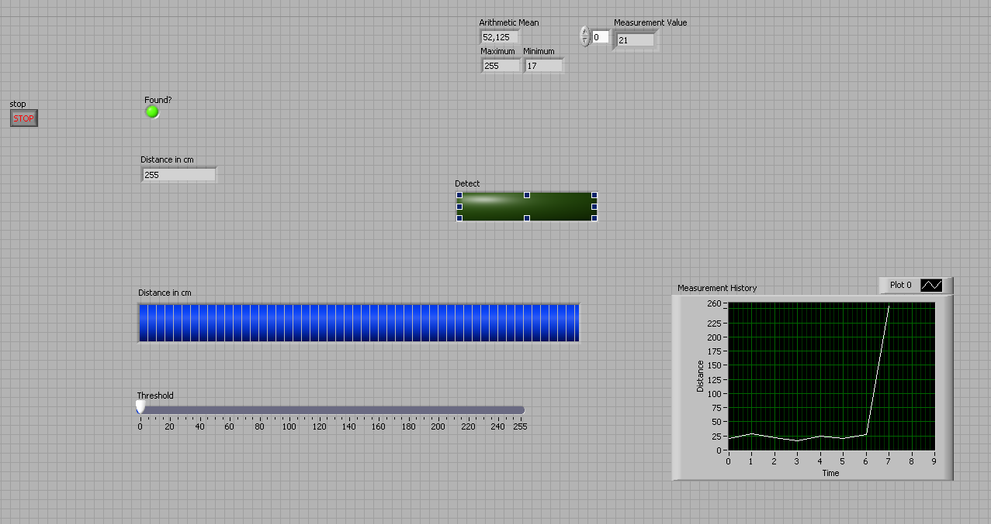

**Task 7: Rotation and position measurement**

**A: Back panel (Design)**

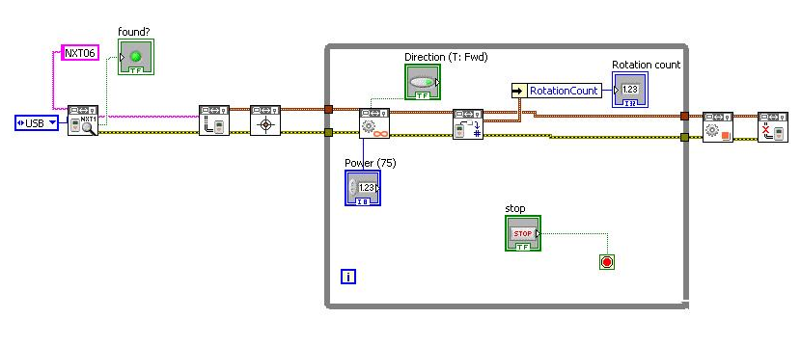

**B: Front panel**

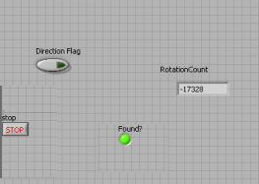

**Task 8: Scan**

**A: Back panel (Design)**

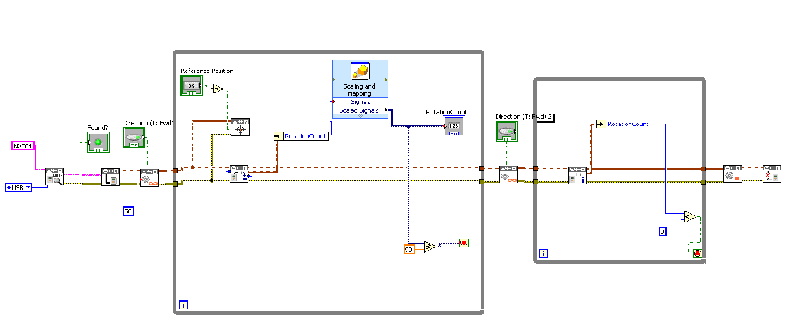

**B: Front panel**

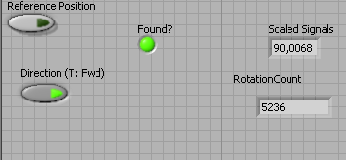

**Task 9: Integration of Ultrasonic Function to scan function**

**A: Back panel (Design)**

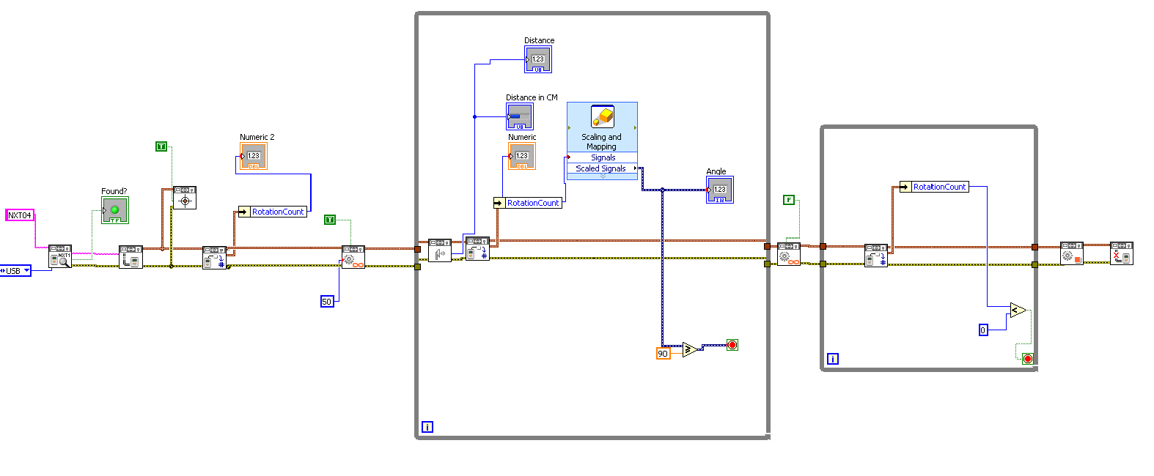

**B: Front panel**

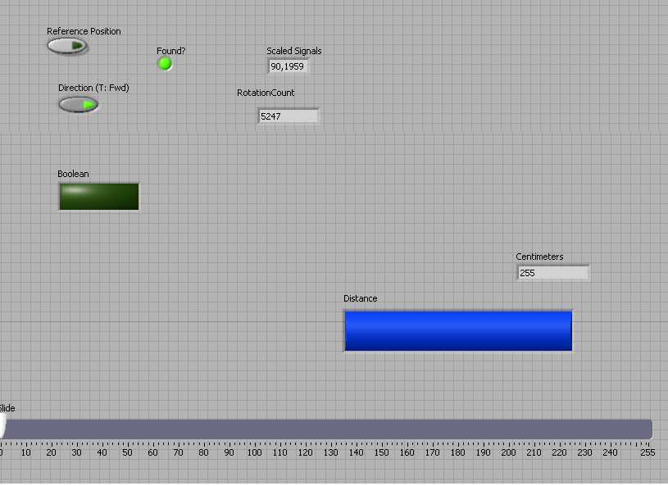

**Task 10: Radar plot**

**B :Front panel**

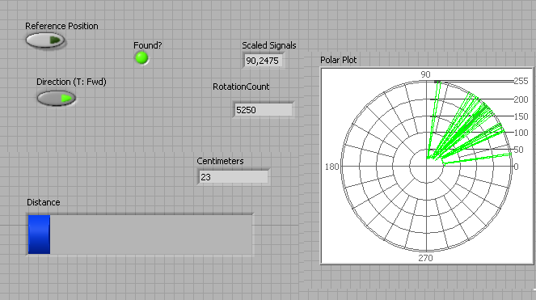

**Task 11: Display measurements and closest object**

**A : Back panel (Design)**

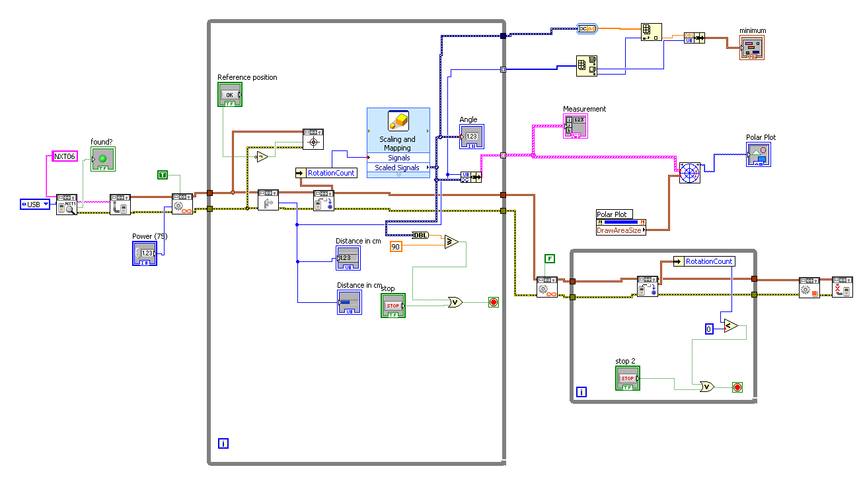

**Because of the time lack , we couldn’t finish this task and the other tasks .**

**Difficulties during the lab:**

Since the LABVIEW was a quite new software for us , It was difficult to find the items we needed during the lab inside the software .